P**lacement of Rank Insignia for Uniforms**

COLLAR GRADE INSIGNIA

1. General.  Wear miniature sized metal grade insig­nia on the collar points of khaki.
2. Description.  Collar grade insignia replicates metal shoulder insignia.
3. Manner of Wearing.  Line officers wear the grade insignia on both collar points.
   1. Long Sleeve Shirt.  On long sleeve shirts that require a collar insignia, center the insignia 1 inch from the front and upper edges of the collar. This procedure applies whether the collar is worn open or closed.
   2. Open Collar Short Sleeve Shirts.  Center the insignia 1 inch from the front and lower edges of the collar and position the vertical axis of the insignia along an imaginary line bisecting the angle of the collar point.

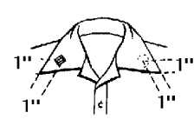

1. REGULAR AND MINIATURE SIZES OF GRADE INSIGNIA.  Regular and miniature sizes of grade insignia have dimensions shown below:

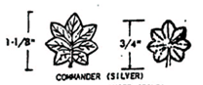

Contact the Commanding Officer (CO), Executive Officer (XO), or Operations Officer for information on wearing rank insignia on the black sweater, black jacket, or black all-weather coat.